RET Lesson:
BECOMING A DATA SCIENTIST
==========================Lesson Header ==========================
Lesson Title: Becoming a Data Scientist
Draft Date: July 19, 2013
1st Author (Writer): Kathleen Luebbe
2nd Author (Editor/Resource Finder): Dr. Parvathi Chundi
Instructional Component Used: Data Analysis
Grade Level: Information Technology 1 Class 9th-12th Grade

Content:
- Data collection
- Data analysis
- Mathematical modeling
- Reporting
Context:
- Video clips
- Prediction pair/share
- Demonstration/lecture
- Spreadsheet lesson
- Visualization software
- Poster presentation

Activity Description:
Students will begin by discussing the job of data scientist in partners and making predictions of what that job entails. They will watch several video clips explaining big data, data collection, analysis, visualization, and the role of a data scientist. Then they will use existing spreadsheets from previous lessons to explore in visualization software. They will do an instructor lead example in the application. Lastly, they will do their own example with a topic that they choose. They must find a variety of statistics and images about their topic and compile their visuals in a poster. Students will present this poster to the class as a role play where they explain the fictitious company, audience, and reasoning for the statistical analysis.

Standards:

Engineering --EB5

Math --ME1, ME2, ME3

Science --SE 2

Computer Science --CT:L2:7, CT:L2:8 CT:L3:MW:4. CCP:L2:2, CCP:L2:3.

Technology –TA1, TA4, TC4, TD3

Materials List:

Video clips
Microsoft Excel
Tableau Public Software (Free Download)
Various software/ cloud-based programs to generate poster
Projector or printer for posters
Accompanying worksheets, directions, observation sheets and rubrics
Asking Questions: (Becoming a Data Scientist)

Summary:
Students will watch several clips regarding big data, data scientists, and data visualization and will be asked to make predictions and answer questions regarding the role of a data scientist.

Outline:
- Discuss careers in Information Technology
- Show video clips
- Answer questions individually
- Pair up and share with neighbors
- Report back to the group

Activity:
Students will listen to the teacher introduce the video concepts. Notes will be taken while watching the film on attached worksheet. (See attached file:
T086_RET_Becoming_Data_Scientist_A_Video_Partner_Questions.docx) Students will share answers to questions on worksheet with assigned partner. Each group will report back to class their reactions. The teacher will then show a quick visual representation of data to peep their interest in data visualization software. See attached file: T086_RET_Becoming_Data_Scientist_A_Storm_Visual.twbx

Questions | Answers
What is a data scientist? | “It’s a high-ranking professional with the training and curiosity to make discoveries in the world of big data” (Davenport 72).
Describe their work/daily tasks | Answers will vary.
What would you enjoy about this career? | Answers will vary.
What would you find challenging about this career? | Answers will vary.
Can you see any drawbacks/negatives about this field? | Answers will vary.
What training do you think is necessary? | Answers will vary.
What is the job outlook? | Answers will vary.
Why is this job necessary? | Answers will vary.

Resources: Data Scientist: The Sexiest Job of the 21st Century. Harvard Business Review Magazine: http://hbr.org/2012/10/datascientist-the-sexiest-job-of-the-21st-century/ar/1
Dawn of the Data Scientist: http://www.youtube.com/watch?v=dH5Ah0yOI5A
The Beauty of Data Visualization: http://www.youtube.com/watch?v=pLqjQ55tz-U
The Joy of Stats: http://www.andrewcohen.com/2012/05/04/the-joy-of-stats/
The River of Myths: http://www.gapminder.org/videos/the-river-of-myths/

Attachments:
T086_RET_Becoming_Data_Scientist_A_Video_Partner_Questions.docx
T086_RET_Becoming_Data_Scientist_A_Storm_Visual.twbx (Tableau Public file)
Exploring Concepts: (Becoming a Data Scientist)
Summary: Students will use previously created spreadsheets in a cloud-based, graphing tool to make data visualizations and summarize their meaning.

Outline:
- Students analyze Excel files they already created.
- Students will find relevant data to input into Tableau Public software.
- Students experiment creating visuals and record their findings.
- Must analyze five other students’ creations.

Activity:
Students will look through spreadsheets they created in previous lessons and think about ways to visually represent their content. The teacher will show a quick demonstration of how to put these Excel files into Tableau Public software and manipulate the graphs. The students will then input their datasets into data visualization software individually. They will have to explain on a worksheet what they created, what it shows them, and who could use this type on information in a business context. Then they will have to share their visuals with their classmates. An example of a very basic visual in tableau public of airplanes that have crashed into birds is below.

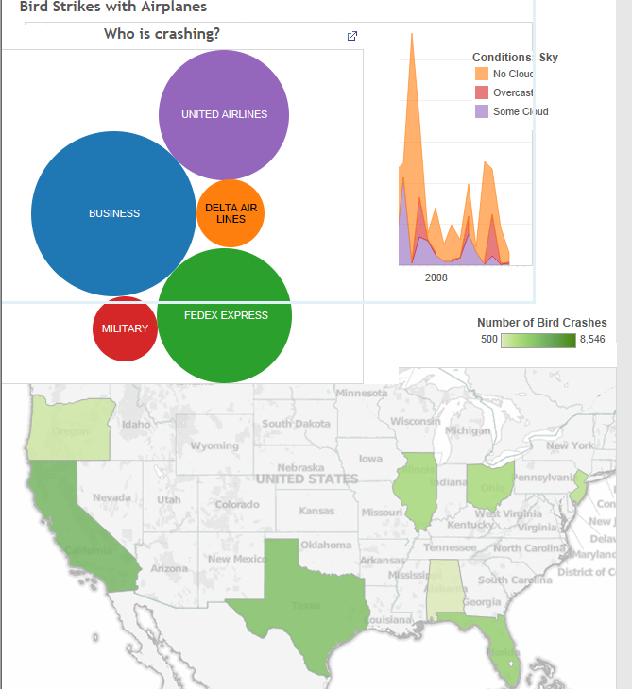

Resources:
Tableau Public Software, Microsoft Excel Software

Attachments: T086_RET_Becoming_Data_Scientist_E_Visualizations.docx
Data Analysis: (Becoming a Data Scientist)

Data analysis is the process of collecting, analyzing, modeling data, and making predictions. The reasons for this process are many but typically the most important are: 1) to find useful information, 2) to make predictions about possible outcomes, and 3) to support and provide evidence for the decision making process.

Data Collection
The process can start with the collection of data using any number of strategies. The data collection might take the form of an experiment where you conduct trials in which you measure the effect of one variable on another by controlling all other possible variables. The collection might be a survey of something by sampling to gather information. It is important that the survey be unbiased, random, and representative of the group you are sampling. Data can be present without going out to collect something new. In the business world it could be historic sales, production, or costs. In academia it can be test scores. In engineering, data is collected on production processes, historical usage or environmental factors, and stress or strength measurements. Data is everywhere and often the problem is not finding data but limiting it to what you are looking to study.

Data Analysis
The analysis of the data that was collected is a critical step. Here you are carefully looking at the data that was collected. It could be in a spreadsheet or other computer application that can organize the data. You probably will want to graph the data because trends are easier to see from a picture. This step is really about identifying trends that might be present. It is possible that there isn’t a strong trend present in the data. If there is not a trend it is not necessarily bad. It just means that the variables are not related.

Mathematical Modeling
Modeling the data that was collected and analyzed is where the mathematics occurs in this process. You can use a graphing calculator, computer spreadsheet or other specialized computer application to generate an equation that represents the data. These uses of technology will also provide statistical measurements like variance and correlation that can help you understand the effectiveness of your equation (model).

Reporting
The final step in this process is to report the data and model that represent it and to make predictions using the model to support decisions. If you have a model that statistically represents the data accurately it should be possible to make fairly reliable predictions. You can present the results in printed form, graphically, or a combination of both. You can show your prediction by showing an extrapolation using your model and present that information as support for a decision. You need to be cautioned that any predictions that are made are only that, a prediction. If the trend changes, your prediction will not be correct. The process of data analysis is a tool to make an educated guess about the future not a guarantee that your prediction will come true.
Organizing Learning: (Becoming a Data Scientist)

Summary: Students will be given a specific audience to create a visual for using a pre-determined dataset. They will have to explain HOW they made their specific visual, WHAT it represents and WHY it is the best one to help a business.

Outline:
- Save dataset into Excel
- Input information into Tableau Public
- Create a visual representation to advise a company
- Write a paragraph description of how, what, and why they are helping a business with their visual

Activity:
The teacher will lead a demonstration in Tableau Public where students will follow steps to create three visual representations of a given data set. This can be done using the attached data set: T086_RET_Becoming_Data_Scientist_O_Worldwide_Cellphone_Subscriptions.xls NOTE: If desired students can complete the RET lesson T088_RET_What_Do_All_Data.doc (relating to Worldwide Cell Phone Subscriptions) to learn how to manipulate information into many different types of visuals. The students will have to take a screen shot of final product to turn in their work. They will also answer questions on worksheet with the screenshot. Then the students will take on the role of a data scientist. They are consultants analyzing data to help a company with a problem. They must create another visual to easily explain this data to the business to help them with decision-making and answer additional questions about their process.

Resources:
Excel
Tableau Public

Attachments: T086_RET_Becoming_Data_Scientist_O_Questions.docx
T086_RET_Becoming_Data_Scientist_O_Worldwide_Cellphone_Subscriptions.xls
Understanding Learning: (Becoming a Data Scientist)
Summary:
Students will create a visual to inform, persuade, or entertain their audience. They will need to find statistics, images, and data to analyze. They will be required to use Tableau Public to make graphs. They will present this to the class and fill out a summary sheet at the end of the project. Students will be graded on a rubric.

Outline:
- Formative assessment of data analysis.
- Summative assessment of data analysis.

Activity:
Students will complete performance assessments related to data analysis using Tableau Public.

Formative Assessment
As students are engaged in lesson teacher will circulate and ask these or similar questions:
- Can students make sense of the data?
- Do students know the goal of their visual representation?

Summative Assessment
Students can complete the following performance assessment.

Students will create a visual and explain it to the class. Students will begin by looking at existing Infographics and evaluating them on the attached worksheet. (attachment 1) This will guide them towards creating their own infographic poster. The teacher will provide data sets. (attachments XXX) The students will look through these Excel files and select one to make their poster about. (Directions in attachment 2) They will need to answer three questions prior to making their poster: WHAT problem are you trying to discover/solve? WHO are you working on this data analysis for? WHAT will be the most important point you want to get across to your audience (inform, persuade, or entertain)? Once they have a plan the can use Powerpoint, Word, a cloud-based infographic creator to visually represent their data. All the requirements are explained in the directions sheet (attachment 2) and attached rubric (attachment 3). At the end of the poster presentations, the student will answer the three questions again and write about the poster creation process. (attachment 4)

Attachments:
- T086_RET_Becoming_Data_Scientist_U_Preposter_Infographic_Evaluation.docx
- T086_RET_Becoming_Data_Scientist_U_Assessment_Directions.docx
- T086_RET_Becoming_Data_Scientist_U_Poster_Rubric.xlsx
- T086_RET_Becoming_Data_Scientist_U_Post_Poster_Questions.docx
- T086_RET_Becoming_Data_Scientist_U_Olympics.xls
- T086_RET_Becoming_Data_Scientist_U_Tale_of_Entrepreneurs.xls
- T086_RET_Becoming_Data_Scientist_U_NYC_Graffiti.csv
- T086_RET_Becoming_Data_Scientist_U_Worldbank_Data.xls
- T086_RET_Becoming_Data_Scientist_U_Bank_Failures.xls

