RET Lesson:
What Do We Do With All This Data?
==========================Lesson Header ==========================
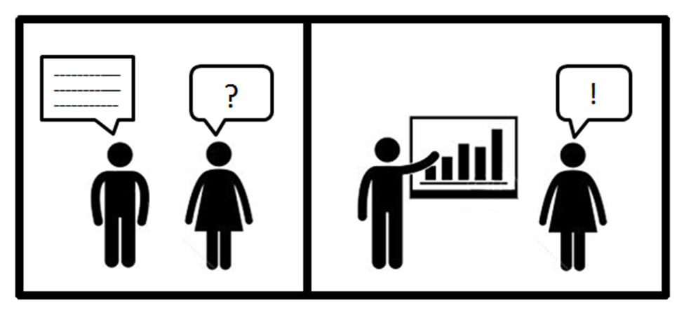
Lesson Title: What Do We Do With All This Data?
Draft Date: July 19, 2013
1st Author (Writer):
Michelle Ledford
Instructional Component Used:
Data visualization
Grade Level: 9-12

Content (what is taught):
- Mathematical modeling using displays of data
Image created by Michelle Ledford
- Data visualization using a software tool
- Data analysis

Context (how it is taught):
- Students will make inquiries about a set of data that is selected.
- Students will represent the data with a graph/chart/map by using a data visualization tool
- Students will analyze the data using their data visualization, answer their original questions, and predict a future outcome.
Activity Description:
In this lesson, students will investigate the importance of creating a good hypothesis (question) before analyzing data to find relationships between the data to see how it can be used.

Standards

Math: MB3, MC4, ME1, ME2, ME3

Science: SA1, SA2, SE1

Technology: TA3, TA4, TB2, TC4, TD1

Engineering: EA1
Computer Science: CT:L2:8, CT:L2:11, CT:L3:MW:4, CT:L3:MW:9, CT:L3:CP:8, CT:L3:CP:9, CL:L2:2, CL:L2:4, CCP:L2:2, CCP:L2:7

Materials List: Tableau Public Software™, mobile computer lab, “Mortality Worldwide” worksheet, “Worldwide Cellphone” data file, Student Directions for Tableau Public worksheet, “Evaluating Data” worksheet, “Directions for Analytic Tools” worksheet, “Buy or Rent” data file, “Complete Volunteer File” data file, “Olympic Athletes” data file, “World Bank Indicators” data file, “Facebook by population” data file, “Mortality Age by country” data file, “New Candidate Planets” data file, “Assessment of Data” worksheet, Data Visualization Project Rubric, Poster Template.

Asking Questions (What do we do with all of this data?)
Summary: Teacher asks leading questions about the content of a set of data, how to analyze the data, and what hypothesis can be made based on this data.
Outline
- Students will be given data.
- What conclusions or patterns are present.
- Students will be asked to consider a hypothesis related to the data.
Activity: The teacher leads a discussion with the students on the content of data, and how to analyze data. The teacher then leads the discussion towards hypotheses about the data, and how to decide what questions are relevant and important. These open-ended questions should be posed as well as the other questions below:
- What do you think this information is about?
- What pattern(s) do you see in the data?
- Can you reach any conclusions about this data?
- Can you make any predictions about this data?
- What can we discover using this data (do you have a hypothesis/question this data could answer?)

Questions | Answers
What is a mathematical model? | A mathematical model is a representation of information using structures such as graphs, equations or algorithms.
What are some approaches to creating and modifying models of real world situations? | Some of the approaches to creating and modifying models of real world situations are linear, polynomial, logarithmic or exponential regression.
What are the different ways of representing a real world situation? What are the benefits of each representation or mathematical tool? | Real world situations can be represented on graphs, maps or charts, all of which are used in data visualization. Any of these representations are beneficial because they combine visual and verbal communication.
What knowledge can be derived from these models? | Comparisons between two or more variables, analysis of relationships, explanation of the data, or further exploration of the data can be derived from these models.
How do we gauge the reliability of that information? | Mathematical models should provide a good fit to the empirical data, and find a balance between accuracy and simplicity.
In what ways can there be more than one right model or answer? | With more than one variable, there are many combinations of relationships, and comparisons that can be modeled, any of these comparisons will be valid for different reasons.
Resources: Abrams, Joshua Paul. “Mathematical Modeling: Teaching the Open-ended
Application of Mathematics.” 2001. Web. July 10, 2013.
Attachments: T088_RET_What_Do_All_Data_A_Mortality_Worldwide_worksheet.xlsx
Exploring Concepts (What do we do with all of this data?)
Summary: Students will download the data found in the Worldwide Cellphone Subscriptions worksheet, and export this data into data visualization software. Students investigate the data by comparing different relationships and creating a visualization of the data and will determine which visualization is the most effective.

Outline:
- Give students the data to download into the data visualization software on their laptops.
- Students will learn some simple functions on the data visualization software with some direction from the teacher.
- Students will then try different comparisons on the software themselves to explore the data.
- Students will download their visualization to a public site to share with the whole class.

Activity: Have students open Tableau Public™ on their laptops and open data by opening the Microsoft Excel file “Worldwide Cellphone Subscriptions,” following oral directions and the handout “Directions for Tableau Public™.” Students will then follow the step-by-step instructions on the handout to learn how to use some of the simple functions. When students have completed these instructions, they will spend some time exploring Tableau Public™ themselves, and try to create different comparisons than the previous ones on the directions. They will download their visualization to Tableau Public™ to share with the class. Students will spend some time viewing each other’s visualizations and answering the questions on the handout “Evaluating Data Visualization.”

Resources: www.TableauSoftware.com

Attachments: T088_RET_What_Do_All_Data_E_Worldwide_Cellphone_datafile.xlsx
T088_RET_What_Do_All_Data_E_Directions_Tableau_worksheet.docx
T088_RET_What_Do_All_Data_E_Evaluating_Data_worksheet.docx

Instructing Concepts (What Do We Do With All This Data?)
Data Visualization
Why do we need data visualization? Data visualization is a way to represent data using two forms of communication: visual and verbal. Using both forms of communication allows the reader to analyze and understand large amounts of data more quickly than just reading text. The world currently produces massive amounts of information that are stored on computers, which help provide convenient access to information, but causes problems with information overload. This makes it more difficult to sift through a large amount of irrelevant or useless data. Data visualization is one of the solutions to this problem and can also inspire new questions and further exploration.

How do we use data visualization? Various algorithms and methods have been created over the years to help deal with the vast amounts of data that are available, but automated data analysis can run into problems when dealing with certain types of data. Often, human intuition and perception can overcome these difficulties. Data visualization is applied to many different types of data from one-dimensional to hierarchies, using many different visualization techniques. It is the dynamic relationship of the data visualization software with human perception that allows relationships in the data to be discovered in innovative ways.

Data visualization vocabulary terms:

Mathematical modeling is the process of studying a question by developing a mathematical model from variables (unknowns) using operators (addition, subtraction, exponents, etc.). A mathematical model is a representation of information using structures such as graphs, equations or algorithms. Sometimes the mathematical models are based on certain simple functions, such as linear, polynomial, logarithmic, or exponential functions. Mathematical models should provide a good fit to the empirical data, and find a balance between accuracy and simplicity.

Data visualization is the representation and presentation of data that uses our visual perception in order to maximize understanding. The representation of data is the way you decide to depict data through a choice of physical forms. For example, a line, a bar, a circle, or any other type of graph or chart. The presentation of data concerns the appearance of your visualization, for example, how you choose colors, annotations, and interactive features. Exploratory data visualization is used to discover what is important about the data. Explanatory data visualization is used to explain what is important about the data. Dynamic projection is interactive data visualization in which consumers can interact and explore the data as well.

Different types of data can be used in data visualization. Data can be one dimensional, such as time-series data, two dimensional, such as geographical maps, or multidimensional, such as relational tables. Data can also be text and hypertext, such as news articles, hierarchies and graphs, such as telephone calls, or algorithms and software, such as debugging operations.

Visualization techniques can be classified as standard 2D/3D displays, such as bar charts and x-y plots, geometrically transformed displays, such as landscapes, icon-based displays, such as star icons, dense pixel displays, such as circle segments, or stacked displays, such as treemaps.
Organizing Learning (What Do We Do With All This Data?)
Summary: Students will explore data, and come up with a hypothesis (question) about their data, and find an answer using a data visualization tool.

Outline:
- Students will choose one of 6-10 data sets (already in .xls format below) to export to Tableau Public™. Students will work with the data on Tableau Public™ to create the “best fit” visualization.
- Students will come up with a hypothesis about their data (either before or during the use of the data visualization software.)

- Students will find solutions to their hypothesis by using the data visualization software and its analytic tools.

Activity: Students will use their instructions for Tableau Public™ to export new data into the program to explore. After students have practiced using some of the simpler functions again, students will create a hypothesis before they use some of the analytic functions of the software. The teacher will provide directions (attached below) for some of the analytic functions on the data visualization software customized for each visualization (some analytic tools do not work with all data). Students will use the data visualization to answer their hypothesis, and create either an explanatory, or exploratory visualization that fits with their hypothesis. Students will share their finished product with the class online. Students will look at and evaluate each other’s visualizations in small groups using the “Assessment of Data Visualization” worksheet.

Resources: www.tableausoftware.com

Attachments: T088_RET_What_Do_All_Data_O_Directions_Analytic_Tools.docx
T088_RET_What_Do_All_Data_O_ Buy_or_Rent_datafile.xlsx
T088_RET_What_Do_All_Data_O_Complete_Volunteer_File _datafile.xlsx
T088_RET_What_Do_All_Data_O_Olympic_Athletes_datafile.xlsx
T088_RET_What_Do_All_Data_O_World_Bank_Indicators_datafile.xlsx
T088_RET_What_Do_All_Data_O_Facebook_by_population_datafile.xlsx
T088_RET_What_Do_All_Data_O_Mortality_Age_by_country_datafile.xlsx
T088_RET_What_Do_All_Data_O_New_Candidate_Planets_datafile.xlsx
T088_RET_What_Do_All_Data_O_Assessment_Data_worksheet.docx

Understanding Learning (What Do We Do With All This Data?)
Summary: Students will create a poster using infographics to summarize what they have learned.

Outline:
- Formative assessment of data visualization.
- Summative assessment of data visualization.

Activity:
Students will write about the process they went through to create their data visualization and evaluate their results.

Formative Assessment
As students are engaged in the lesson the teacher walks around and asks these or similar questions:

- Do students understand what type of relationships can be found when looking at data?
- Can students explain what type of representation of the data will work best for their particular data?
- Do students know what some questions we could ask about their data are?
- Do student know what they might be able to predict with their data?

Summative Assessment
Students will create a poster explaining their data visualization that will answer the following questions:

- What did you initially discover about the data?
- What was your initial hypothesis, and did it change as you explored the data with the data visualization software?
- What type of data did you choose, and what type of visualization technique?
- Why do you think the data visualization you chose for the data is the best fit for your hypothesis?

Attachments: T088_RET_What_Do_All_Data_U_Project_Rubric.docx
T088_RET_What_Do_All_Data_U_Poster_Template.ppt

