Notebook

Purpose of the notebook is to document project work by providing:
- A chronological history of development
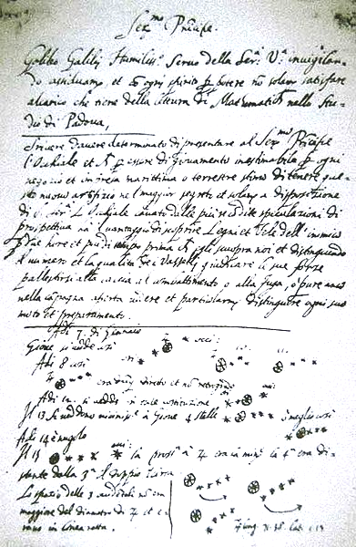
Galileo Notebook Page
Source: Wiki Commons
- A topic based summary of methods and results
- An overall summary and project evaluation

Importance of a notebook:
- Engineers use notebooks as a legal document
- Designers use notebooks as evidence of first discovery or invention

To view historical notebooks search Google Images for:
- Engineer notebook
- Marie Curie notebook, Galileo Galilei notebook
- Nikola Tesla notebook, Thomas Edison notebook

Notebook Checklist

Choose one of these notebook formats:
- Paper notebook with sections
- Or a series of online documents

Include these sections or separate online documents:
- Daily entries
- Topic entries

Daily entries should include:
- Date and time, name of person writing entry, names of other people present
- Daily goals or task list which may involve multiple topics with mixed goals
- Activities or tasks completed with sufficient detail to understand significance
- Pictures, graphs, or diagrams as needed to illustrate activities or tasks
- Daily summary which describes what was accomplished
- Future work to be done next

Topic entries should include:
- Information about a single topic
- Procedures and methods that enables efficient duplication of results
- Pictures, graphs, or diagrams as needed to illustrate procedures and methods
- Research information and references

Notebook summary should include:
- Overall results of the project
- Evaluation of results
- Project reflection and future plans

