Programming Piecewise Functions “O” Supplemental Materials

Initial conditions that students will be encoding in Java are included in the image below.

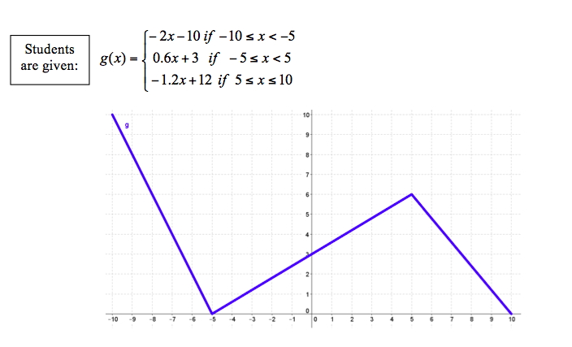

Student output for “O” component of T095_RET_Programming_Piecewise_Functions.docx

Below is a solution for the Organizing component of the lesson
public class PieceWiseFunctions

{
/**
* A class for generating outputs to piecewise a piecewise function, g(x)
*/
public static void main(String[] args)
{
//5 is the input that can be changed
double input = 5;
System.out.println(input + ", " + g(5));
//Print out a value of input, g(input)
}

public static double g(double x)
{
double gOfx = 0;
if(x >= -10 && x < -5)
gOfx = -2*x - 10;
if(x >= -5 && x < 5)
gOfx = 0.6*x + 3;
if(x >= 5 && x <= 10)
gOfx = -1.2*x + 12;
return gOfx;
}
}
