Students will complete a performance assessment related to computer programming.

Students will write Java code that computes the taxes for individuals filing as “Single”. They will be given a copy of Schedule X from the 2013 IRS Revenue Tax Guide (Publication 17, Catalog Number 10311G, pg 263 - http://www.irs.gov/pub/irs-pdf/p17.pdf) and a portion of the 2013 IRS Tax Table (http://www.irs.gov/pub/irs-pdf/i1040tt.pdf) in order to test the accuracy of their code. NOTE: They can test their code by inputting an income of a tax payer filing as Single and ensuring the amount matches (after rounding) the tax owed according to the table).

After writing and testing their code, students will fill out the included table and compute the taxes owed by all of the people who are filing as Single. The filled-in table, along with a print out of the student’s code will be collected and assessed for grading.

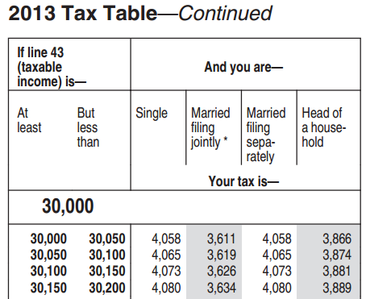
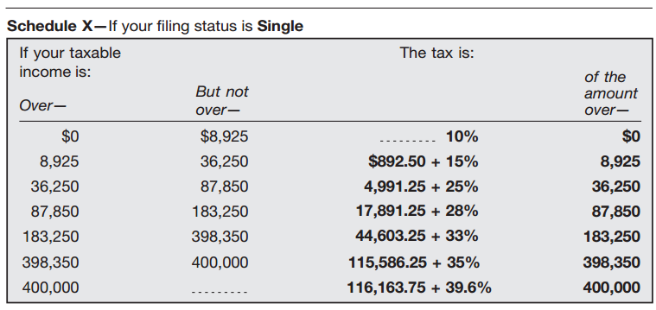

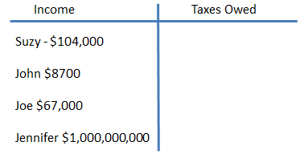
Calculate the taxes of each individual filing as “Single” below.

