RET Lesson:
Putting the Squeeze on Data
==========================Lesson Header ==========================
Lesson Title: Putting the Squeeze on Data
Draft Date: 7/10/2014
1st Author (Writer): Jeremy Long
2nd Author (Editor/Resource Finder):
Instructional Component Used: Data Compression
Grade Level: 9-12
Cartoon Illustration Idea:

Content (what is taught):
- Investigating Compression techniques
- Understanding a short history and vocabulary of Compression
- Applying a Huffman encoding/decoding techniques

Context (how it is taught):
- Manipulating both images and texts to explore the concepts of lossy and lossless compression
- Obtaining a basic knowledge of compression through a short lecture
- Applying a Huffman encoding/decoding technique manually
- Automating a Huffman encoding/decoding technique using Python
Activity Description:
Students will learn about data compression techniques through hands-on activities, lectures and programming. A majority of the time will be using either hands-on activities or programming activities with a short lecture mixed in to establish a basic history and vocabulary of data compression. Hands on activities include investigations of lossy compression with both images and text as well as lossless activities with text including LZ and Huffman techniques. Students will also be guided through the development of a simple Huffman encoder and decoder using the Python programming language. Students will be asked to reflect on their learning on a daily basis.

Standards: (At least one standard each for Math, Science, Engineering and Technology - use standards provided)

Math Science
MA1, MA3, MB2, MC2, ME4 SE1, SE2

Technology Engineering
TB2, TC4, TD2 EB1, EB5, EC1,
Computer Science
CT:L2:7,8,11,14, CT:L3:MW:5, CT:L3:CP7, CCP:L2:4
Materials List:
Windows, Apples OSX or Linux based computer system installed with a Python IDE and Microsoft Excel.
Asking Questions (Putting the Squeeze on Data)

Summary: Students consider the concepts and necessity of data compression.

Outline:
- Students relate the concepts of compression to everyday activities.
- Students consider the importance of compression and data loss
- Students will take a text and remove “unimportant” letters to see how much they can remove and still have the message be readable.

Activities:
For the first activity, the teacher will introduce the computer science topic of data compression including the basic types of compression and the scenarios in which one would consider one compression method over another. Possible discussion questions are given below.

In the second activity, the student takes a well-known text such as a speech and removes letters, often vowels to reduce the number of letters needed to understand a text. See attached file ofr details: T096_RET_Putting_Squeeze_on_Data_A_lossy text.doc This would be an analog to image or sound compressions, where subtle (and sometimes not-so-subtle) changes are made to compress the data that should not affect the user’s consumption of the piece.

Questions | Answers
How do you pack for a trip? a 1 wk trip?, 2 wk trip?, to Hawaii?, to Alaska? | Answers vary. You are looking for ideas like organization, selection, reuse, etc.
How is compression used in the “real world”? | To compress music, videos, television, text, etc.
What are some compression names/acronyms that you have seen or used? | GIF, JPEG, MPEG, MP3, ZIP, etc.
When compressing data, in what cases would you care about not losing data? In what cases would you care? | Losing data: Sound, images, etc.  Not Losing data: Text, financial data, etc.

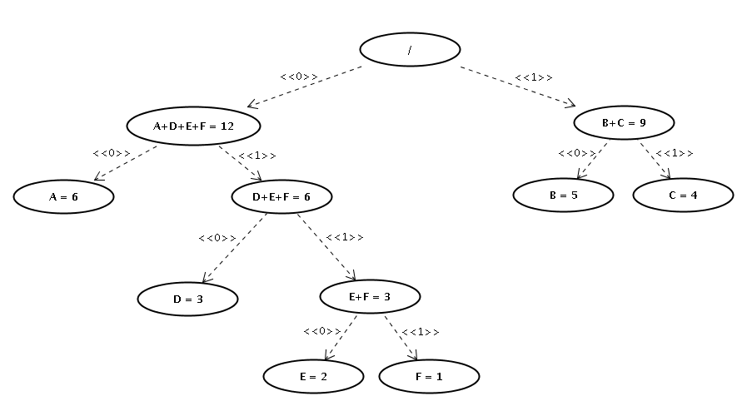
http://commons.wikimedia.org/wiki/File:Huffmanpasso6.png
Attachments:
T096_RET_Putting_Squeeze_on_Data_A_lossy text.doc
Exploring Concepts (Putting the Squeeze on Data)

Summary: Use hands-on compression techniques to explore lossy and lossless compression.

Outline:
- Students will pixelate an image to see how far they can take it and still recognize the figure.
- Students will take a text with repeated phrases and use an LZ77 compression to simplify the code.

Activity:
In the first activity, the student takes and image and uses a 16 x 16 grid and a selection of 16 grayscale colors to compress an image similar to how a GIF image compression simplifies the number of colors used in an image. The student uses a pre-made Microsoft Excel worksheet that takes advantage of Excel’s conditional formatting feature to color an image. Students should get an appreciation for how basic image compression works and get an understanding of the tradeoff in compression and image quality.

The second activity uses the basis for the lossless LZ77 compression technique to compress the text in a nursery rhyme. The LZ77 compression technique uses an ordered pair to represent repeated text. For example, in the nursery rhyme, “Old King Cole was a merry old soul, And a merry old soul was he. . . “ the second “ a merry old soul” can be represented by < 22,17> where 17 represents the repeated number of letters and offset from the original by 22.

Resources:
Additional compression ideas and activities can be found at the following web addresses.
- http://www.csunplugged.org/image-representation
- http://www.csunplugged.org/text-compression

Attachments:
- T096_RET_Putting_Squeeze_on_Data_E_gif_key.xls
- T096_RET_Putting_Squeeze_on_Data_E_gif_student.xls
- T096_RET_Putting_Squeeze_on_Data_E_lz class example.doc
Instructing Concepts (Putting the Squeeze on Data)

Data Compression:
In a data-rich world, data compression is necessarily important for efficient communication especially over wireless networks. Data compression is often traced back to Morse code where more commonly used letters are less intensive to encode, such as the letter ‘e’ whose representation is a ‘dot.’ Modern data compression falls into two broad categories: lossy and lossless. Lossy compression, as the name suggests, “lose” non-essential data in the compression process to save space. This lost data is unrecoverable once the data is decompressed. Lossless data compression, on the other hand, compresses data in such a way that all data is recoverable during the decompression process.

Learning Data Compression:
As we move into an era with wearable computing, the idea of ubiquitous computing is being born into reality. Lying beneath this omni-present computing is the necessary data that is collected, computed, disseminated, assembled and compiled through wired and wireless networks. Because of this, efficient data compression techniques are fundamental to this new world of computing. Knowing the type of compression that is used as well as its basic algorithms, benefits and limitations is becoming an essential understanding within the field of computer science.

Common Data Compression Techniques:
Lossy Data Compression Techniques:
- Often used with sound, image and video files.
- Based on eliminating unnecessary (unnoticeable) data.
- Common acronyms of techniques: GIF, JPEG, MP3 and MPEG.
- Example: GIF pseudo-algorithm.
  - GIF compression uses both lossy and lossless techniques.
  - GIF compression reduces image colors from 256x256x256 to a library of 256.
  - GIF uses an LZW lossless compression to further reduce the amount of data.

Lossless Data Compression Techniques:
- Used when it is essential to keep all data: medical monitoring, transmitting text, etc.
- Based on simplifying redundant information.
- Entropy is the least number of bits needed to encode a message.
- Popular lossless compression techniques: Huffman encoding, LZ(W) and arithmetic.
- Example: Huffman pseudo-algorithm.
  - Huffman Coding is a library coding technique.
  - Each letter has a unique prefix-free encoding determined by a binary tree.
  - Letters with a high frequency (probability) are given a short binary encoding.
  - Letters with a low frequency are given longer encodings.

Organizing Learning (Putting the Squeeze on Data)

Summary: Students complete a Huffman encoding activity consisting of both manual encoding techniques and Python programming techniques

Outline:
- Students will take a text and remove “unimportant” letters to see how much they can remove.
- Students will take notes on compression.
- Students will complete an activity guide for manual Huffman encoding.
- Students will program a Huffman coder/decoder in Python via guided instruction. (The coder will also count bits saved as a secondary output.)

Activities:
Students will take notes on a brief overview of compression and compression techniques. Sample lecture notes are attached. The notes lead into an activity where the students see an example of Huffman encoding and then are given the opportunity to follow the encoding themselves. Finally, students can take what they have manually done and see how to do a similar activity using a programming language. (Note: the Python programming examples provided are designed for a first semester Introduction to Computer Science course. Because of this, the procedures have been kept simple and do not find a truly optimum compression of the text. More advanced Huffman coding techniques can be downloaded from the internet.)

Resources:
A short video on Huffman encoding can be found on YouTube:
Upside Down Trees (Huffman Trees) – Computerphile http://www.youtube.com/watch?v=umTbivyJoiI

Attachments:
T096_RET_Putting_Squeeze_on_Data_O_compression notes.docx Compression notes.
T096_RET_Putting_Squeeze_on_Data_O_Huffman_Coding_Activity _Sheet.doc
T096_RET_Putting_Squeeze_on_Data_O_Sample_Python_Huffman_encoder.zip

Zip File Contains:
T096_RET_Putting_Squeeze_on_Data_O_ Sample_Python_Huffman_Encoder.txt
T096_RET_Putting_Squeeze_on_Data_O_ Sample_Python_Huffman_Decoder.txt
T096_RET_Putting_Squeeze_on_Data_O_Getty.txt

Understanding Learning (Putting the Squeeze on Data)
Summary: Students will be evaluated through topical reflections of activities and manual compressions utilizing Huffman encoding.

Outline:
- Formative assessment of data compression.
- Summative assessment of data compression.

Activity:
Students will be observed and will journal reflections on the topics of lossy compression, lossless compression, entropy/efficiency, Huffman encoding and Huffman trees.

Formative Assessment
As students are engaged in the lesson ask these or similar questions:
- Do students understand the difference between lossy and lossless compression over a multi-day exploration?
- How will I know whether the students are just following the formula versus understanding the concept when students are learning to calculate entropy/efficiency of lossless encoding?
- How can I be sure that all students have the appropriate math skills to complete the activities with Huffman encoding, (and for entropy/efficiency as well)?
- What are some quick checkpoints that assure that the students’ Huffman tree models are correct without limiting their tree to an exact copy of my own?
- How can I make sure that students are relating all activities to the number of bits saved in a compression algorithm?

Summative Assessment
Students can complete one of the following writing prompt.
- Describe what data compression is and why it is important.
- Explain the Huffman data compression method and how it functions.

Students can complete the following performance assessment.
- Easy Assessment: Give the student a library of Huffman codes and an encoded text, have the students complete the following:
  - Decode the text
  - Describe the entropy and efficiency of the algorithm.
- Comprehensive Assessment:
  - Find the probability for each letter in a text.
  - From the probabilities, develop a Huffman tree.
  - Using the prefix-free binary mappings from the Huffman tree, develop an encoding library.
  - Use the library to encode a message.
  - Decode the same message – matching the decoded letter to a parsed portion of the binary string.
  - Determine the entropy/efficiency of the Huffman code for the provided text.

