RET Lesson:
Let's Talk About My Generator
Lesson Title: Let's Talk About My Generator (Hurricane Network Generators)
Draft Date: July 7, 2014
1st Author (Writer): Laura Book
2nd Author (Editor/Resource Finder): Sanjukta Bhowmick
Instructional Component Used: Graph Theory
Grade Level: 6-8
Cartoon Illustration Idea:

Content (what is taught):
- Science (Weather, Natural Disasters, and analyzing graphs)
- Math (graphing and analyzing graphs)
- Technology (graph theory nodes/edges)

Context (how it is taught):
- Visualization
- Hands On Activities
- Data Entry and Analyzing
Activity Description:
Students will be taught the graph theory vocabulary, theories behind graph theory, and theories/processes behind network generators. The students will then use this information to create many different sample networks before creating their own simple versions of hurricane networks. The real life hurricane network will be posted in the room and the students regenerated versions will be placed around it. The students will then make comparisons of similarities and differences between the original graph and the ones they create.

Standards:

Math: MC4, MD1, ME2 Science: SD1, SF3

Technology: TA3, TC4 Computer Science: CL:L1:6, CL:L2

Materials List:

- Data Sample Set (attached example: sample sets, connections, relationships)
- String (I used yarn of different colors 3-5)
- List of hurricanes and their strengths(in the sample set provided, may need to be updated)
- Computers
- Microsoft Excel
- Cytoscape (free download if from the web(http://www.cytoscape.org/))
- List of data to be entered into Excel/Cytoscape(in the sample set provided)
Asking Questions (Let's Talk About My Generator)

Summary: Learning graph theory vocabulary, how network generators work, and what they can be used for.

Outline:
- Students will learn vocabulary related to graph theory.
- Students will discuss what is their community, what are their relationships, what would nodes and edges look like in this context?

Activity: Students will be guided through a PowerPoint that will help them learn the vocabulary surrounding graph theory. As the teacher presents the material, answers to the questions below can be discussed. After the PowerPoint, a class discussion will be conducted centered around how these concepts can be applied to their lives. Consider the following questions: what is their community, what are their relationships, what would nodes and edges look like in this context?

Questions | Answers
What is a Network Generator? | A computer program that contains an algorithm that will create a duplicate network (similar but not exact).
What does a Network Generator do? | Recreates a network by using an algorithm (set of instructions).
How can we use Network Generators? | To create/recreate networks of science topics that will help us to visualize the relationships between items.
What is a community? | A grouping of nodes with similar features
What is a relationship? | The features that create a community.  Such as: having the same number of siblings, being in the same group or class, going to the same school.
Image Idea:
Created in PowerPoint by Laura Book Hurricanes: Created in Cytoscape by Laura Book
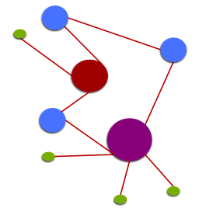
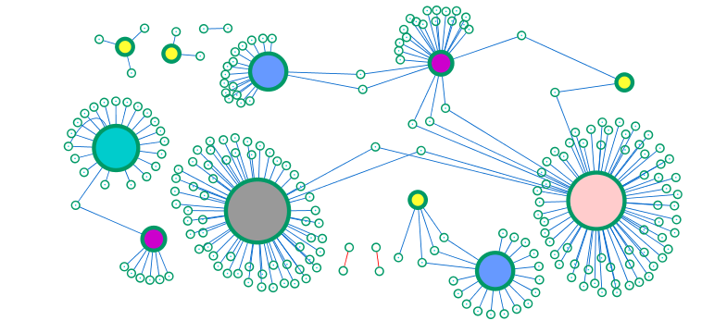

Attachments:
T097_RET_Lets_Talk_Generator_A_Intro1.ppt

Exploring Concepts (Let's Talk About My Generator)

Summary: Students will be given sample sets of instructions to follow in order to recreate different networks. These instructions would be considered the algorithms that the computers follow in order to create networks.

Outline:
- Complete 3 different PowerPoints that will reiterate vocabulary related to graph theory.
- Students will draw networks by hand
- Students will use the proper vocabulary to discuss their graphs.

Activity: Students will be presented with 3 different PowerPoints that will strengthen their knowledge of graph theory vocabulary. As part of the process, they will be able to describe the size, number of nodes and number of connections. They will also be asked to draw networks by hand given fewer and fewer instructions as the activity goes on. Below is a description of what each PowerPoint includes.

PowerPoint 1 (Network Generators) – in class 10-15 min instructions on following instructions and creating networks, these networks will be very simple. They will describe the size of nodes, number of nodes, number of edges, and number of connections.

PowerPoint 2 (Networking Communities) – in class 10-15 min instructions on communities and how they can show up in clusters to create different types of networks, these networks will become more complex. They will describe how to cluster the nodes into separate communities, the number nodes, number of edges, and number connections within and outside of communities.

PowerPoint 3 (Networking Venn Diagrams) – in class 10-15 min instructions on relationships and how they can be grouped in a Venn Diagram style in order to create the network, these networks will again become more complex. They will describe how to cluster the nodes into communities and how those communities are overlapping, the number nodes, number of edges, and number connections within and outside of communities.

Attachments:
T097_RET_Lets_Talk_Generator_E_NetworkGenerators.ppt
T097_RET_Lets_Talk_Generator_E_NetworkingCommunities.ppt
T097_RET_Lets_Talk_Generator_E_NetworkingVennDiagram.ppt

Instructing Concepts (Let's Talk About My Generator)

Graph Theory

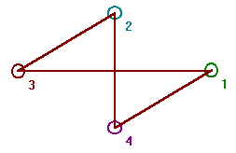
Graph theory is the mathematical study of graphs. A graph consists of a set or collection of vertices or nodes and a set or collection of edges that connect the vertices. As an illustration, a graph defined by vertex set V={1, 2, 3, 4} and edge set E={(1, 3), (1, 4), (2, 3), (2, 4)} would have the diagram shown to the right. Vertices that are connected by an edge are said to be adjacent. The degree of a vertex is the number of edges connecting to the vertex as an end point. In the example graph to the right, all vertices have a degree of 2. Some of the different types of graphs are the complete graph and the regular graph. A complete graph is a graph where every vertex is adjacent to every other vertex. A regular graph has the same degree on all vertices.
An adjacency matrix for a graph with n vertices is an n x n matrix where entry (i, j) is 1 if there is an edge in the graph between vertex i and j, otherwise the entry is 0. The adjacency matrix shown to the right is for the graph shown above.

An adjacency list for a graph has a row for each vertex and contains the vertex label followed by the vertex labels of adjacent vertices. The adjacency list for the graph above would be:

A path in a graph from vertex v to u is a sequence of edges where the first edge starts at v, each successive edge connects to the previous edge, and the final edge terminates at u. A path from 1 to 2 in the graph above would be: (1, 3), (3, 2). A vertex v is reachable from vertex u, if there is a path from v to u. A graph is connected, if every vertex is reachable from every other vertex, otherwise the graph is considered disconnected.

A graph traversal is the process of visiting every vertex of a graph. There are a number of algorithms or methods of graph traversal with the most common being depth first search (DFS) and breadth first search (BFS). Considering a given node as the parent and connected nodes as children, DFS will visit the child vertices before visiting siblings, where as BFS will visit the siblings vertices before the child vertices. DFS and BFS have their own special applications. DFS for example is useful in creating or solving mazes. BFS is more useful finding a winning strategy in games.

Attachments:
DFS and BFS Algorithms: I_Tech_020_Graph_Theory_DFS_BFS_Algorithms.doc

Organizing Learning (Let's Talk About My Generator)

Summary: Students will be inputting hurricane data from a given list into Excel. They will then use their knowledge of the sorting tool to sort and create communities for the data they were given. Next the students will import this information into the Cytoscape program to create a graph of the hurricane data.

Outline:
- Students will be creating a network from a given data set.
- Students will first type this information into an excel spreadsheet and sort this information to get an idea of how many different communities they might have in their given information.
- The students will then import the excel data into a Cytoscape in order to create a graph.
- The students will then be allowed to change the style of their Cytoscape graph and make it more visually appealing.
- Finally the students will analyze the graph in comparison to the data. Noting the communities that it shows and the strengths of connections for each location.

Activity:
Students will be given a grouping of data from the hurricane information found in the Excel attachment. They will input this information into an Excel spreadsheet and organize (sort) it in a way that groups their data into communities (as they now understand what would be needed to be considered a community from the mini lessons found in the PowerPoints). The students will then import the information into a Cytoscape program in order to create a graph that they can use to show their communities. They will manipulate the settings in Cytoscape to produce a graph that they feel represents the network. Finally, they will analyze the information they see on their graphs and describe how grouped the information.

Attachments:
T097_RET_Lets_Talk_Generator_O_AffectedAreas2012.xls

Understanding Learning (Let's Talk About My Generator)

Summary: Given a set of data and information about number of connections, nodes, edges, and communities: students will be able to graph said data and then compare their graph to an original network graph. Students will compose a short essay of what they see/recognize/can infer based on the connections they formed on previous graphs created in class.

Outline:
- Formative assessment of graph theory.
- Summative assessment of graph theory.

Activity:
Students will be given written and performance assessments related to graph theory.

Formative Assessment
As students are engaged in the lesson ask these or similar questions:
- What do you see? (Looking for an answer about nodes, edges, connections, and communities.)
- What do you think can be inferred by the smaller communities? Why?
- What do you think can be inferred by the larger communities? Why?
- How are the original and the duplicated graphs similar?
- How are the original and the duplicated graphs different?

Summative Assessment
Students can answer one of the following writing prompts.
- What are nodes, edges, and communities? How do they relate to one another?
- Given the image below, what can you tell about the network?

Students can complete the following performance assessment.
Students will regenerate a graph by hand from a set of given instructions and then compare it to the original graph by describing how the original and the recreated graph are similar and different. Next, they will input data into an excel program, followed by then importing that data into a cytoscape to create a graph. They will compare this duplication of a graph with theirs and the original. They will finally complete a summary of what the networks have taught them about hurricanes.

