RET Lesson:
“Scratch”-ing the Surface
Introduction to Programming with Business Students
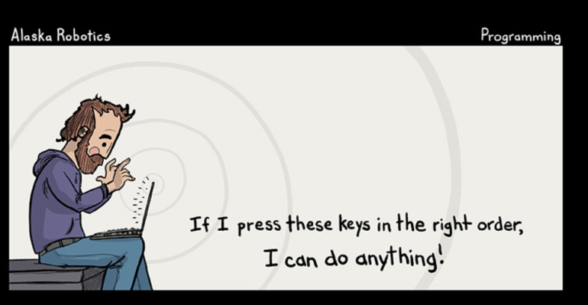
==========================Lesson Header ==========================
Lesson Title: Scratching the Surface
Draft Date: July 7, 2014
1st Author (Writer): Kathleen Luebbe
2nd Author: Dr. Qiuming Zhu
Instructional Component: Computer Programming
Grade Level: 9-10

Image Source: http://alaskarobotics.com/comics/2013/02/18/programming

Content (what is taught):
- Exposure to Computer Programming
- Using the Scratch Program
- Importance of computers in business

Context (how it is taught):
- Running existing programs
- Modifying and adding to code
- Video clips and class discussions

Activity Description:
Students will be introduced to computer programming by using the Scratch program. Students will be introduced to the idea of coding during journal writing, short video clips, and class discussions. When they explore with digital stories and games on the Scratch website they will see how code makes interesting applications. They can “look inside” and see how the premade coding blocks can be put together to solve a problem or tell or story. They will take an existing project in Scratch and add their own code to it as a first try at computer programming. Finally, they will be expected to communicate their learning during formative assessment (questions and teacher observation) and summative assessment (written test with screen shots of code and questions).

Standards:

Math Science
MB1 MA2 SE1

Computer Science Engineering
CT:L2 6,14,15 CL:L3:CP 3 CCP:L1 6 EA1 EA4 EB4 EB6 EC1
CD:L3 CP CCP:L2 5,8

Materials List: Computers, Internet Access.

Asking Questions (Scratching the Surface)
Summary: Students think about computer programming from a business perspective.

Outline:
- Students will consider the importance of computer programming through a business lens.

Activity:
Teacher will post 3-5 questions on the board for students to journal about at the start of class. Then class will watch two short clips from code.org and madewithcode.com (links below). Lastly, the students will discuss how business people need computer programming. Possible discussion questions are given below.

Questions | Answers
How do computers help businesses? | Inventory systems, point of sale registers, customer tracking, ordering, sensors, etc.
What is a computer program? | Look up definition on the Internet and discuss the different findings. Teacher will share definition from business dictionary.
What have you ever wondered about computer programming? | Answers vary.
What does an IT department of a company do? | Technical support, networking, security, database administration, software, hardware, web, multimedia, design, architecture, etc.

Image Idea:


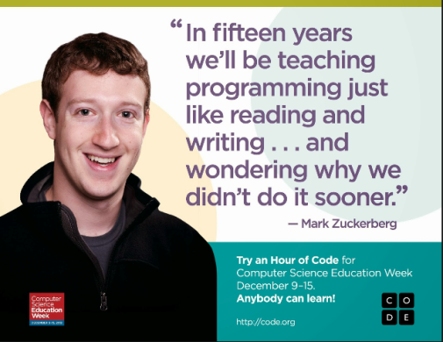

www.code.org www.madewithcode.com

Resources:
http://www.businessdictionary.com/definition/computer-programming.html

Exploring Concepts (Scratching the Surface)
Summary: Students will look at existing projects and explore the code necessary for those games to run.

Outline:
- Students will understand that code can make online stories, games, etc. to share with people around the world by looking at the gallery and playing existing Scratch scenes.
- Students will “See what’s inside” of other projects.
- Students will learn how the code makes the programs work.
- Students will changing blocks of code and see what they can modify, add, and enhance.
Activity:
Scratch is an online environment that allows users to code stories, games, and other programs using premade drag and drop blocks. This helps students think logically to compile blocks into a working program. Programming vocabulary such as “variables” and “if…then…else statements” are easily taught when put blocks together and run programs. Students will go to http://scratch.mit.edu/ and click on the gallery to explore other people’s scratch creations. Then they will click “look inside” to see how the blocks were compiled to make the projects. Lastly they will modify the code to enhance and change the project. For detailed instructions and a student organizer see attached file: T099_RET_Scratching_Surface_E_Directions.doc
Image Idea:
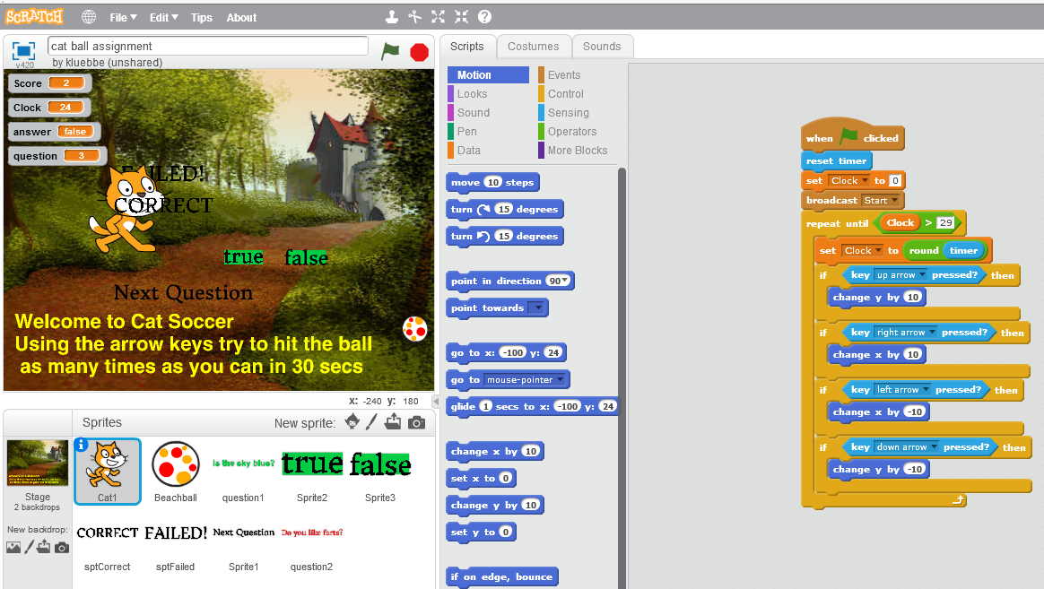

Resources:
www.scratch.mit.edu
Attachments:
T099_RET_Scratching_Surface_E_Directions.doc
Instructing Concepts: (Scratching the Surface)

Computer Programming

Computer programming is the process of writing code that will cause a machine to do something desired by the user. In addition to the writing or modifying of the program code, programming includes the process of testing and debugging that code to make it work properly. The computer programmer must be able to think logically and sequentially in order for the program to work.

History

The history of electronic computer programming began in the 1940’s with the invention of the ENIAC machine. This first modern computer was developed by the military to help with the writing of artillery-firing tables. These tables were used for different weapons that were fired under varied conditions for target accuracy. As computers improved through the 1950’s to the 1970’s, languages like COBOL for business and FORTRAN for science and engineering were developed and became the standard. With the invention of the personal computer in the 1980’s computers became household items and the number of languages grew and diversified. Pascal and BASIC were languages that sprung up in the 1980’s as a result of the PC. As the computer continues to get more powerful, the languages continue to adapt. Some of the more prevalent languages today are the various iterations of C, Java, PHP, and numerous others.

Basic Instructions of Computer Program (In Almost Any Language)

Input: The acquisition of data from a file, keyboard or other input device.

Mathematical Functions: The performance of mathematical operations ranging from basic arithmetic to advanced functions.

Repetition: The performance of an action over and over, sometimes with subtle changes.

Conditional Algorithms: The checking for certain conditions and the execution of statements in an appropriate sequence.

Output: The displaying of data resulting from the program on a screen, in a file, or any other means.

Characteristics of Modern Computer Programs

Modern programs look and do very different things but share some common characteristics. They all try to be efficient and high performance thereby providing the most power and speed while using the least amount of system resources. They should be reliable. Programs should be robust in dealing with the user and how they handle errors and data conflicts. The program should be usable, clear in its output and intuitive for its user. Finally the program should be portable across a wide range of operating systems and hardware.

Organizing Learning (Scratching the Surface)
Summary: Students complete an assignment in programming with a Scratch project (economics quiz game) created by the teacher.

Outline:
- Students play a quiz game created by the teacher on economic concepts.
- Students examine the existing code to understand how the program works.
- Students must make changes to code to learn basic computer programming.

Activity:
Students will go to http://scratch.mit.edu/projects/24265596/ which takes them to a quiz game on economic pricing factors. They will play this game to understand what it does. Then they will then “look inside” and evaluate the code to understand the programming behind the scenes. They will have to make three changes to the code and explain on a worksheet (see attached file: T099_RET_Scratching_Surface_O_worksheet.doc) what they changed and how it affected the execution of the program. Next, they will have to add two more economic questions to the game. This will allow them perform basic programming with the help of example code to follow.

Resources:
http://scratch.mit.edu/projects/24265596/

Attachments:
T099_RET_Scratching_Surface_O_Worksheet.doc
Understanding Learning (Scratching the Surface)

Summary: Students will be evaluated through observations, questions, and testing.

Outline:
- Formative assessment of computer programming.
- Summative assessment of computer programming.

Activity:
Students will complete written and test assessments related to computer programming

Formative Assessment
As students are engaged in the lesson ask these or similar questions:
- Do students understand what the added code blocks do?
- Can students explain why the creator made variables?
- Can students design a program similar to this one?

Summative Assessment
Students can answer the one of the following writing prompts.
- Describe what a sprite is in the scratch program?
- Pick three different code blocks, identify what code blocks you selected and what they do.

Students can complete the following test.
For the test see attached file: T099_RET_Scratching_Surface_U_Test.doc

Attachment:
T099_RET_Scratching_Surface_U_Test.doc

