Answer the following questions related to programming in Scratch. You may use computer and the website: http://scratch.mit.edu/
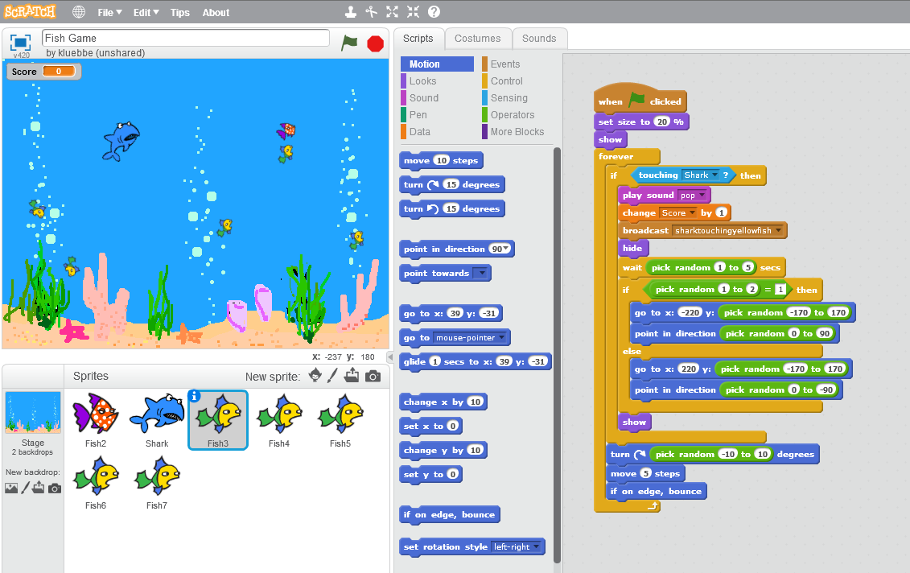
1. Which sprite is selected? _____________________________
2. Look at the code and explain the script for that sprite. ___________________________________________________________________________________________________________________________________________________________________________________________________________________________________________________________________________________________________________________________________________________________________________________________________________________________________________________________
3. What “event” kicks off this script? ___________________________________________________________________
4. Be very detailed and explain what happens “forever” ______________________________________________________________________________________________________________________________________________________________________________________________________________________________________________________________________________________________________________________________________________________________________________________________________
5. How does the “random” block affect this sprite?
___________________________________________________________________________________________________________________________________________________________________________________________________________________________________________________________________________________________________________________________________________________________________________________________________________________________________________________________
6. Explain either “if” statement.
___________________________________________________________________________________________________________________________________________________________________________________________________________________________________________________________________________________________________________________________________________________________________________________________________________________________________________________________
BONUS: Make a shark sprite that chases the yellow fish. Take a screen shot of your creation and insert below.

